Institute of Systems Science
National University of Singapore

MASTER OF TECHNOLOGY IN
ENTERPRISE BUSINESS ANALYTICS

Unit 3 Examination

Subject: Data Analytics

Sample Examination Questions

SECTION A

Question 1 (Total: 10 Marks)

A Conjoint project was conducted in class where three variables - university, university ranking, and course fees - were considered. Sample data from the project is given in figure 1 overleaf. Answer the following questions:
- Briefly describe the objective, questionnaire design, target respondents and sample, and method of data collection.
(4 Marks)

Objective- To see the preference of university based on attributes such as university,university ranking and course fees.

See theory and design of conjoint studies(ratings based model) ---- obtained from net
Questionnaire design:

0----------------------------------------------50------------------------------------------------100
Bad univ excellent
Proposal 1:
University: NUS
University Fees: $50k
Tier: 1
Duration: 1.5

Your rating:

Proposal 1:
University: NTU
University Fees: $50k
Tier: 1
Duration: 1.5

Your rating:

Target respondents: Will be parents of prospective university/college beginning students as well as students about to join the universities. This will give an unbiased rating.

Sample :
Method of data collection:
https://thesis.eur.nl/pub/7938/7938-Maria.pdf
The choice of the data collection method There are several alternative methods available for the collection of the conjoint data. 4 alternatives are discussed.
1) Full profile method Under this method respondents are asked to rank order, rate and etc., a set of objects that differ from one another on two or more attributes and that are defined on all attributed which are included in the study. The disadvantage of this method is the big possibility of information a task overload.
2) Trade-off method Under this method respondents are asked to rank each combination of levels of two attributes, from most preferred to least preferred. A big disadvantage is to construct a matrix in case there are more than 2 attributes, because if we got a n attributes we need to construct a (n(n-1))/2 matrices.
3) Paired comparison method Under this method respondents are asked to choose between two objects at a time, and choose the one preferred. These objects can be defined on all attributes included in the study or they 10 can be defined on a subset of all attributes. The disadvantage of the method is that the paired comparisons increase fast as the number of objects increase.
4) Attributed Stated choice method Under this method respondents are as well asked to choose between objects, that are defined on all attributes in the study. This method can be divided in three groups. 1) Best –scaling, where the respondent chooses the best object 1) One pair best-worst scaling, where the respondent chooses the best and worst objects 2) Two pair best-worst scaling, where the respondent chooses 2 best and the 2 worst objects.

- 238 records were found. Suppose that using Microsoft Excel the following estimates of the parameters were calculated with NUS as base reference for brand:
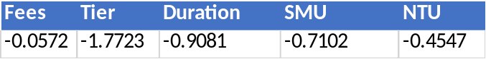
Write down the utility function for each of the three universities
(Hint: U_{j} = β_{0j}+β_{1j}+…). State the limitation of this output. Is it possible to comment on the order of importance of all the three variables to run the analyses.
NTU
Uj= -0.0572(Fess NTU 40k) -0.0572(Fess NTU 50k) -0.0572(Fess NTU 60k)-1.7723(Tier 1)-1.7723(Tier 2)-(0.7102)(Duration 1)-(0.7102)(Duration 1.5)-0.4547

SMU
Uj= -0.0572(Fess SMU 40k) -0.0572(Fess SMU 50k) -0.0572(Fess SMU 60k)-1.7723(Tier 1)-1.7723(Tier 2)-(0.7102)(Duration 1)-(0.7102)(Duration 1.5)-0.7102

NUS
Uj= -0.0572(Fess NUS 40k) -0.0572(Fess NUS 50k) -0.0572(Fess NUS 60k)-1.7723(Tier 1)-1.7723(Tier 2)-(0.7102)(Duration 1)-(0.7102)(Duration 1.5)

Limitation:
The utility scores of levels of each attribute give better understanding

Order of importance: It is not possible to calculate the importance unless the range of each level (utility score) is known.

(3 Marks)
- As the market dynamic changes, NTU and NUS are now both Tier 1 universities with SMU still remaining as Tier 2. Both NTU and NUS offer a 1.5 year degree course but SMU offers 1 year course. Fees for NTU, NUS and SMU are S$50K, S$50K and S$40K respectively.
Based on the developed Conjoint model in part (b), determine the market shares of NUS, NTU and SMU. Complete your exercise by doing appropriate research.
(3 Marks)

Tier University Duration Fees
Tier 1 NUS 1.5 50
Tier 1 NTU 1.5 50
Tier 2 SMU 1 40

Adding fees +tier+duration we get -2.7376
So SMU we get -3.4478
NTU we get -3.1923
NUS we get -2.7376

Among the three NUS has higher score followed by NTU and then SMU. So we split the 263 records as 110 NUS, 78 NTU and 75 SMU
So market share of
NUS=110/263=>41.8
NTU=78/263=>29.6
SMU=75/263=>28.5

Attribute: Tier,Rate,Duration

Levels: Tier: 1,2

Rate: 40,50,60

Duration- 1.5,1

Fees: 50, 50, 40
University: NTU, NUS and SMU

Figure 1: Sample Data from the Conjoint Project
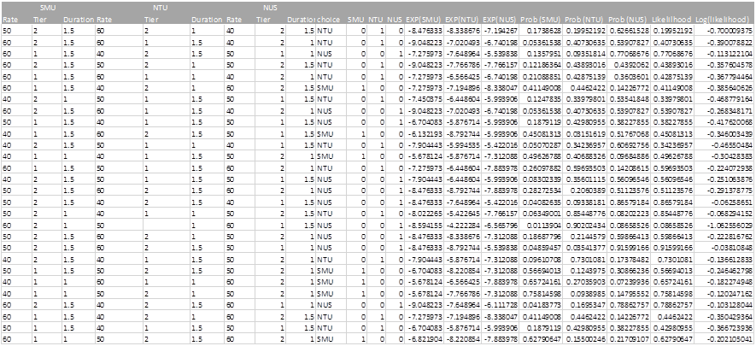

Question 2 (Total: 15 Marks)

720 patients with primary node positive breast cancer have been recruited into a clinical study to assess the effectiveness of hormone therapy. Researchers collected complete data on the 10 covariates for 686 of these patients as shown in figure 2. Survival analysis was performed on these patients with recurrence time as the survival time variable and recurrence status as the censoring variable. A subset of the data is shown in figure 3.
  - Provide two scenarios where censoring would occur in this study.
(2 Marks)
1.If a person does not experience recurrence before study ends
2.A person is lost to follow up during study period
3. A person withdraws from study
http://www.stat.columbia.edu/~madigan/W2025/notes/survival.pdf

  - What can you deduce from the Kaplan-Meier survival curves shown in figure 4

The pattern of one survivorship function lying above other means group defined by upper curve lived longer than the group defined by the lower curve. In other words at any point in time the proportion of subjects estimated to be alive is greater for one group(upper curve) than the other(lower curve). harmone therapy lived longer than no harmone therapy.

c.
c. A printout from R of the log–rank test is given below. What conclusions can you draw from these results?
Results of the Log-Rank Test

Call:
survdiff(formula = Y ~ bc$hormone, data = bc)

N Observed Expected (O-E)^2/E (O-E)^2/V
bc$hormone=No 440 205 180 3.37 8.56
bc$hormone=Yes 246 94 119 5.12 8.56

Chisq= 8.6 on 1 degrees of freedom, p= 0.00343

(2 Marks)

Null hypothesis: Survival curve in both groups are the same
Alternate hypothesis: Survival curve in both groups are different
Since chisq=8.6 with p=0.00435 , p <0.05 so we reject the null hypothesis. Hence, survival in both curves are different

http://www.mas.ncl.ac.uk/~njnsm/medfac/docs/surv.pdf

  - Using age, menopause status, hormone therapy, tumor size, tumor grade, number of nodes, number of progesterone receptors, and number of estrogen receptors as predictor variables, the backward stepwise selection technique was adopted to develop an appropriate Cox Proportional Hazard model. Based on the R outputs given in figure 5, select the best Cox Proportional Hazard model and write down the model equation. Discuss how the final model was chosen using backward stepwise selection from the initial model.
(4 Marks)
Since all the independent variable have p value <0.05 I use the model with lowest AIC to determine the best model.The best among the four is the fourth with the lowest AIC value of 3485.68 which has the following x’s hormone + size + grade + nodes + prog_recp.
The models using the backward selection have all reducing AIC values. This method is used for selection of variables.

The equation used is
log hi(t) = α + β1xi1 + β2xi2 + · · · + βkxik
log hi(t)= α + β1 hormone + β2size + β3grade + β4nodes + β5prog_recp
size should not be included as p value is less

  - Interpret each regression coefficient of the model you selected in part (d).

Answer: (3 Marks)

coef exp(coef) se(coef) z p
hormoneYes -0.32352 0.724 0.125824 -2.57 1.0e-02
size 0.00731 1.007 0.003890 1.88 6.0e-02
grade2 0.64403 1.904 0.249018 2.59 9.7e-03
grade3 0.78823 2.199 0.268258 2.94 3.3e-03
nodes 0.04900 1.050 0.007453 6.57 4.9e-11
prog_recp -0.00222 0.998 0.000554 -4.00 6.3e-05

Likelihood ratio test=103 on 6 df, p=0 n= 686, number of events= 299

For one unit
0.00731 unit increase in expected log of the relative hazard for size, holding other coefficients constant
E0.00731 = 1.00713
7.13 % increase in cancer by unit increase in size of tumor.

Holding other covariates constant, An additional increase in harmoneyes reduces the survival time by a factor of eb2=0.724 on an average that is by 27.6%
Holding other covariates constant, an additional increase in size increases the survival time by a factor of eb3= 1.007 i.e by 0.7%(does this make sense logically?)

http://www.pitt.edu/~super4/33011-34001/33091-33101.ppt
e-0.32352 =0.72360
72.3% increase in cancer with one unit increase/decrease in harmone???(not sure)

  - Explain the critical assumption underlying your model.
(2 Marks)

https://www.stat.ubc.ca/~rollin/teach/643w04/lec/node69.html

First and foremost is the issue of non-informative censoring. To satisfy this assumption, the design of the underlying study must ensure that the mechanisms giving rise to censoring of individual subjects are not related to the probability of an event occurring. For example, in clinical studies, care must be taken that continuation of follow-up not depend on a participants medical condition. Violation of this assumption can invalidates just about any sort of survival analysis, from Kaplan-Meier estimation to the Cox model.
The second key assumption in the Cox model is that of proportional hazards. In a regression type setting this means that the survival curves for two strata (determined by the particular choices of values for the -variables) must have hazard functions that are proportional over time (i.e. constant relative hazard). We have seen how this can be evaluated graphically using "log-log" plots in the two-sample comparison case. In that situation, and also for the Cox model, there are tests that can be applied to test proportionality.
Test of proportional hazards assumption
If the test from the prop hazards is insignificant then there is no evidence to contradict hazards assumption.
Figure 2: Variable Description
Variable | Description
age | Age at diagnosis (years)
menopause | Menopausal status (No, Yes)
hormone | Hormone therapy (No, Yes)
size | Tumor size (millimetre)
grade | Tumor grade (1, 2, 3)
nodes | Number of nodes involved
prog_recp | Number of progesterone receptors
estrg_recp | Number of estrogen receptors
rectime | Time to recurrence (days)
censrec | Recurrence censoring (0 = Censored, 1 = Recurrence)
Figure 3: Sample Data
age | menopause | hormone | size | grade | nodes | prog_recp | estrg_recp | rectime | censrec
38 | No | No | 18 | 3 | 5 | 141 | 105 | 1337 | 1
52 | No | No | 20 | 1 | 1 | 78 | 14 | 1420 | 1
47 | No | No | 30 | 2 | 1 | 422 | 89 | 1279 | 1
40 | No | No | 24 | 1 | 3 | 25 | 11 | 148 | 0
64 | Yes | Yes | 19 | 2 | 1 | 19 | 9 | 1863 | 0
49 | Yes | Yes | 56 | 1 | 3 | 356 | 64 | 1933 | 0
53 | Yes | No | 52 | 2 | 9 | 6 | 29 | 358 | 1
61 | Yes | Yes | 22 | 2 | 2 | 6 | 173 | 2372 | 1
43 | No | No | 30 | 2 | 1 | 22 | 0 | 2563 | 0
74 | Yes | Yes | 20 | 2 | 1 | 462 | 240 | 2372 | 0
Figure 4: Kaplan-Meier Survival Curves
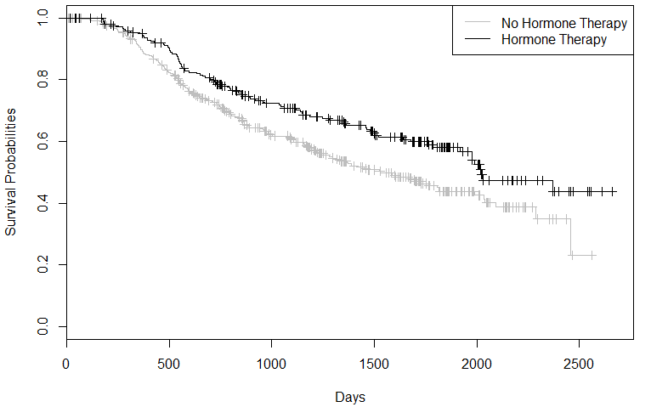
Figure 5: Cox Proportional Hazard Model R Outputs
> Y <- Surv(bc$rectime, bc$censrec == 1)
> coxph.fit1 <- coxph(Y ~ age + menopause + hormone + size + grade +
nodes + prog_recp + estrg_recp, data = bc)
> coxph.fit1
Call:
coxph(formula = Y ~ age + menopause + hormone + size + grade +
nodes + prog_recp + estrg_recp, data = bc)

coef exp(coef) se(coef) z p
age -0.009459 0.991 0.009301 -1.017 3.1e-01
menopauseYes 0.258445 1.295 0.183476 1.409 1.6e-01
hormoneYes -0.346278 0.707 0.129075 -2.683 7.3e-03
size 0.007796 1.008 0.003939 1.979 4.8e-02
grade2 0.636112 1.889 0.249202 2.553 1.1e-02
grade3 0.779654 2.181 0.268480 2.904 3.7e-03
nodes 0.048789 1.050 0.007447 6.551 5.7e-11
prog_recp -0.002217 0.998 0.000574 -3.866 1.1e-04
estrg_recp 0.000197 1.000 0.000450 0.438 6.6e-01

Likelihood ratio test=105 on 9 df, p=0 n= 686, number of events= 299

> coxph.fit2 <- step(coxph.fit1, direction="backward")
Start: AIC=3489.46
Y ~ age + menopause + hormone + size + grade + nodes + prog_recp +
estrg_recp

Df AIC
- estrg_recp 1 3487.7
- age 1 3488.5
- menopause 1 3489.4
<none> 3489.5
- size 1 3491.2
- hormone 1 3494.9
- grade 2 3495.3
- prog_recp 1 3507.5
- nodes 1 3519.5

Step: AIC=3487.65
Y ~ age + menopause + hormone + size + grade + nodes + prog_recp

Df AIC
- age 1 3486.6
- menopause 1 3487.7
<none> 3487.7
- size 1 3489.3
- hormone 1 3493.0
- grade 2 3493.5
- prog_recp 1 3506.8
- nodes 1 3517.6

Step: AIC=3486.56
Y ~ menopause + hormone + size + grade + nodes + prog_recp

Df AIC
- menopause 1 3485.7
<none> 3486.6
- size 1 3488.1
- hormone 1 3492.3
- grade 2 3492.6
- prog_recp 1 3506.6
- nodes 1 3516.4

Step: AIC=3485.68
Y ~ hormone + size + grade + nodes + prog_recp

Df AIC
<none> 3485.7
- size 1 3487.0
- hormone 1 3490.5
- grade 2 3491.8
- prog_recp 1 3506.1
- nodes 1 3515.9

> coxph.fit2
Call:
coxph(formula = Y ~ hormone + size + grade + nodes + prog_recp,
data = bc)

coef exp(coef) se(coef) z p
hormoneYes -0.32352 0.724 0.125824 -2.57 1.0e-02
size 0.00731 1.007 0.003890 1.88 6.0e-02
grade2 0.64403 1.904 0.249018 2.59 9.7e-03
grade3 0.78823 2.199 0.268258 2.94 3.3e-03
nodes 0.04900 1.050 0.007453 6.57 4.9e-11
prog_recp -0.00222 0.998 0.000554 -4.00 6.3e-05

Likelihood ratio test=103 on 6 df, p=0 n= 686, number of events= 299

SECTION B

Question 3 (Total: 6 Marks)

- Describe briefly what is meant by the term “overfitting” when used in the context of building a prediction model.
(1 mark)
- Overfitting in Machine Learning
Overfitting refers to a model that models the training data too well.
Overfitting happens when a model learns the detail and noise in the training data to the extent that it negatively impacts the performance of the model on new data. This means that the noise or random fluctuations in the training data is picked up and learned as concepts by the model. The problem is that these concepts do not apply to new data and negatively impact the models ability to generalize.
Overfitting is more likely with nonparametric and nonlinear models that have more flexibility when learning a target function. As such, many nonparametric machine learning algorithms also include parameters or techniques to limit and constrain how much detail the model learns.
For example, decision trees are a nonparametric machine learning algorithm that is very flexible and is subject to overfitting training data. This problem can be addressed by pruning a tree after it has learned in order to remove some of the detail it has picked up.
- Underfitting in Machine Learning
Underfitting refers to a model that can neither model the training data nor generalize to new data.
An underfit machine learning model is not a suitable model and will be obvious as it will have poor performance on the training data.
Underfitting is often not discussed as it is easy to detect given a good performance metric. The remedy is to move on and try alternate machine learning algorithms. Nevertheless, it does provide a good contrast to the problem of overfitting.

- A Good Fit in Machine Learning
Ideally, you want to select a model at the sweet spot between underfitting and overfitting.
This is the goal, but is very difficult to do in practice.
To understand this goal, we can look at the performance of a machine learning algorithm over time as it is learning a training data. We can plot both the skill on the training data and the skill on a test dataset we have held back from the training process.
Over time, as the algorithm learns, the error for the model on the training data goes down and so does the error on the test dataset. If we train for too long, the performance on the training dataset may continue to decrease because the model is overfitting and learning the irrelevant detail and noise in the training dataset. At the same time the error for the test set starts to rise again as the model’s ability to generalize decreases.
The sweet spot is the point just before the error on the test dataset starts to increase where the model has good skill on both the training dataset and the unseen test dataset.
You can perform this experiment with your favorite machine learning algorithms. This is often not useful technique in practice, because by choosing the stopping point for training using the skill on the test dataset it means that the testset is no longer “unseen” or a standalone objective measure. Some knowledge (a lot of useful knowledge) about that data has leaked into the training procedure.
There are two additional techniques you can use to help find the sweet spot in practice: resampling methods and a validation dataset.

- How To Limit Overfitting
Both overfitting and underfitting can lead to poor model performance. But by far the most common problem in applied machine learning is overfitting.
Overfitting is such a problem because the evaluation of machine learning algorithms on training data is different from the evaluation we actually care the most about, namely how well the algorithm performs on unseen data.
There are two important techniques that you can use when evaluating machine learning algorithms to limit overfitting:
- Use a resampling technique to estimate model accuracy.
- Hold back a validation dataset.
The most popular resampling technique is k-fold cross validation. It allows you to train and test your model k-times on different subsets of training data and build up an estimate of the performance of a machine learning model on unseen data.
A validation dataset is simply a subset of your training data that you hold back from your machine learning algorithms until the very end of your project. After you have selected and tuned your machine learning algorithms on your training dataset you can evaluate the learned models on the validation dataset to get a final objective idea of how the models might perform on unseen data.
Using cross validation is a gold standard in applied machine learning for estimating model accuracy on unseen data. If you have the data, using a validation dataset is also an excellent practice.
You learned that generalization is a description of how well the concepts learned by a model apply to new data. Finally, you learned about the terminology of generalization in machine learning of overfitting and underfitting:
- Overfitting: Good performance on the training data, poor generliazation to other data.
- Underfitting: Poor performance on the training data and poor generalization to other data

- Give one symptom of overfitting when building a Neural Network.
(1 mark)

  - Poor Accuracy &
  - Poor Performance
  - By building a very complex model, it's quite easy to perfectly fit our dataset. But when we evaluate such a complex model on new data, it performs very poorly. In other words, the model does not generalize well.
  - Networks can be overtrained. It means that they memorize the training
set and are unable to generalize well. Generalization is the ability of a network to correctly classify a pattern it has not seen (not been trained on)
  - Having too many layers or training the NN to long often causes it to
precisely fit the training data – but this usually makes a poor predictor!
E.g. we wish to predict income from a persons age
- Over fitting is due to Over training.

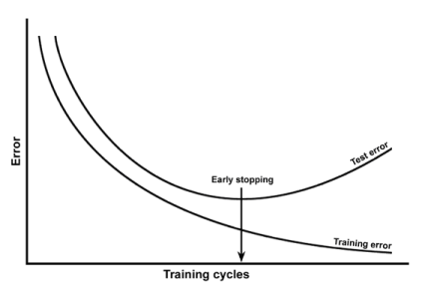

- Assume that a Neural Network has been built and that overfitting is detected. It is decided to rebuild the Neural Network. For each of the options listed below, state whether it would or would not help prevent overtraining in the new network. Justify (explain) your answers.

(4 marks)

- Increase the training time –
- Doesnot help to prevent over Training
- training time is one of the Criteria to STOP Training.
- Training the Model should be time based
- stop training after the error drops to a fairly low level
- Decrease the number of nodes in the hidden layer
- Number of nodes in the hidden layer Helps to prevent over Training
- Hidden nodes ~ approximately.., where nin and non are respectively the number of input and output nodes (Timothy Masters)
- sqrt( nin x non)
- eliminate unnecessary hidden‐layer nodes & weights
- Add an extra hidden layer
- Doesnot Helps to prevent over Training
- Hidden nodes ~ approximately.., where nin and non are respectively the number of input and output nodes (Timothy Masters)
- sqrt( nin x non)
- eliminate unnecessary hidden‐layer nodes & weights
- Use fresh random initial weights
  - It Helps to prevent over Training
  - Randomly adding weights to the Input variables .
  - It eliminates adding a fixed weight all the time the
  - speed at which the ideal weights (A) are reached
- Increase the number of training examples
  - It Helps to prevent over Training
  - Your model will be trained with more examples rather than the same examples always
- Increase the number of input variables (input nodes)
  - Doesnot Helps to prevent over Training

Question 4 (Total: 7 Marks)

- You have been asked to build an ensemble classifier comprising 10 decision tree models using a set of 1000 training examples. You have also been asked to ensure that each of the 1000 training examples should be used at least once during model building (ie: should be used as a training record for at least one of the trees). Which of the following three model building methods would you recommend? Explain your answer:
  - Build the 10 trees by bootstrap sampling (with replenishment) of 90% of the training data for each tree.
  - Build the 10 trees by bootstrap sampling (without replenishment) of 90% of the training data for each tree.
  - Build the 10 trees using 10-fold cross validation with 9-folds being used for each tree.
(2 Marks)
- This would be a recommended model
- Because – Data set is split into K Groups without overlapping
- Prediction will be with less error rate & with more accuracy
- Train N models (e.g. Neural Nets) using N‐fold cross‐validation
  - Train on N‐1 folds and stop training early
  - Use held‐out fold to do parameter optimization
  - Repeat for all sets of N‐1, At the end you have N models
    - Then, instead of retraining on all data with new parameters, keep N models and
- average predictions
  - Often safer/easier than retraining from scratch

- When building a random forest classifier, should over-fitting of the training data by the trees within the forest be avoided? Explain you answer.
(2 Marks)
- YES . over fitting of the training data can be avoided.
- Reduce variance without increasing bias
- Random forest helps to reduce the Error and increase accuracy & decrease the variance

- When building a single decision tree classifier using a decision tree learning algorithm, the first feature (variable) appearing in the tree (ie: the feature that is tested in the tree root node) is generally considered the most important feature in the dataset with respect to the classification task. However, when building a random forest to perform the same classification task, the first feature that appears in each tree in the forest cannot be considered the most important feature. Explain why this is the case.
(3 Marks)
For a single tree the order in which the variables occur in the tree is a measure of
their relative importance to the prediction
• For a forest?
– Naïve method: Count the number of times the variable occurs in all of the trees, more
occurrences => more important
– Better method: sum the total reduction in impurity (the decreases in the Gini index) for
all nodes that test the variable

Question 5 (Total: 7 Marks)

Below are confusion matrices showing the performances of three prediction models that have been built to perform a binary classification task (with class values = true, false). The test set used contained 100 examples of which 41 have class value = true (T) and 59 have the class value = false (F). The rows in the confusion matrices show the number of actual values in each class and the columns show the number of predicted values in each class. A fourth confusion matrix is also shown which shows the performance of an ensemble of the three prediction models. The voting method used by the ensemble was that only if all three individual models agreed on the predicted class value, would a prediction be made, otherwise no prediction would be made. Hence the ensemble has three prediction outcomes, T, F and U (unknown).
 |  | predicted
 | actual | T | F
model1 | T | 27 | 14
 | F | 13 | 46
 |  | predicted
 | actual | T | F
model2 | T | 33 | 8
 | F | 8 | 51
 |  | predicted
 | actual | T | F
model3 | T | 32 | 9
 | F | 17 | 42
 |  | predicted
 | actual | T | F
ensemble | T | 16 | 0
 | F | 1 | 26

Answer the following questions:
- Is the precision of the ensemble higher than that of the best individual model? Show your calculations.
(3 Marks)
 |  | predicted
 | actual | T | F
model1 | T | 27 | 14 | 41
 | F | 13 | 46
 |  | 40 | 60
 |  |  | Precision = 27/40 = 67.5%
   | T | F
  T | TP = 27 | FN = 14
  F | FP = 13 | TN  =46
 |  | predicted
 | actual | T | F
model2 | T | 33 | 8 |  |  |  | 41
 | F | 8 | 51
 |  | 41 | 59
Precision = 33/41 = 80.48
 |  | predicted
 | actual | T | F
model3 | T | 32 | 9 |  | 41
 | F | 17 | 42
 |  | 49 | 51
Precision = 32/49 = 65.3%
 |  | predicted
 | actual | T | F
ensemble | T | 16 | 0 |  |  | 16
 | F | 1 | 26
T= 17 F= 26
Precision = 16/17 = 94.11

ANS: Yes. the precision of the ensemble higher than that of the best individual model. ( 80.48%)

Model 1 : Precision = 27/40 = 67.5%
Model 2 : Precision = 33/41 = 80.48 %
Model 3 : Precision = 32/49 = 65.3%
Ensemble : Precision = 16/17= 94.11 %

- Is the recall of the ensemble higher than that of the best individual model? Show your calculations. We define recall here as the percentage of the actual true examples that was predicted as true.
(3 Marks)

ANS: Yes. the recall of the ensemble higher than that of the best individual model.
( 80.48%)

Model 1 : Recall = 27/41 = 65.85%
Model 2 : Recall = 33/41 = 80.48 %
Model 3 : Recall = 32/41 = 78.04%
Ensemble : Recall = 16/16= 100 %

- If the ensemble voting rule was changed to only require a majority vote then would you expect the precision of the ensemble model to increase or decrease? Similarly, would you expect the recall to increase or decrease? Explain your answer.
(1 Mark)
Precision and recall will decrease. TRUE and FALSE cases will increase and Unknown values will be decreased. Hence the Ensemble precision and recall will be decreased .

SECTION C

Question 6 (Total: 15 Marks)

The monthly passenger numbers of an airline over 11 years (132 months) are shown below in figure 6.
- Using multiplicative decomposition method, 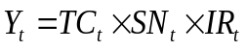, the average seasonal indices for a twelve month period are as follows:
The trend component is found to be TC = 2.5539t + 92.494 where:
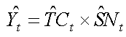
- Give an intuitive explanation of your understanding of the seasonal pattern.
(2 Marks)
- Using the developed model, provide a projection for the first half of year 12.
(3 Marks)

- ARIMA models have been applied to the passenger data shown in figure 1:
- The passenger data is not a stationary series. How can this be overcome?
(2 Marks)

- Two modeled results of the series are shown below in figures 7 and 8:
  - Comment on the validity of the two results and recommend your model of choice.
(4 Marks)
  - Based on your recommendation in part (1), write the full expression of the forecast summary (Y_{t} = … Y_{t-n}.. Y_{t-m..}) using the coefficient estimates given in figures 2 and 3 (Hint: use the backshift B operator to express and expand the equation).
(4 Marks)

Figure 6: Monthly Airline Passenger Numbers
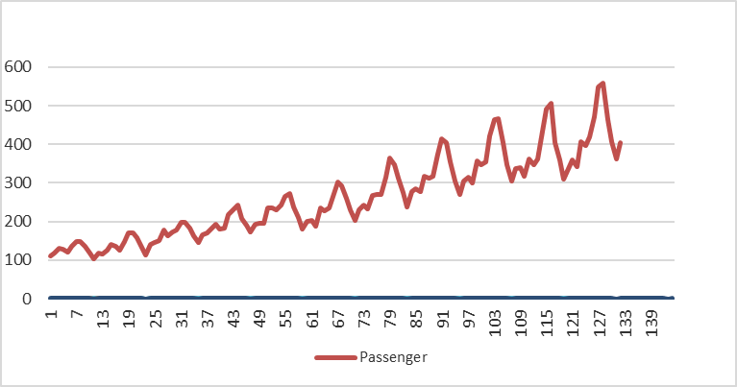
Figure 7: First Model Results
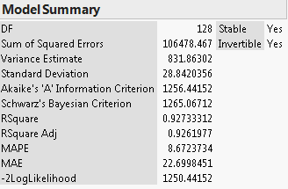
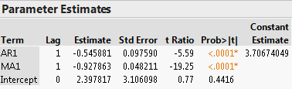
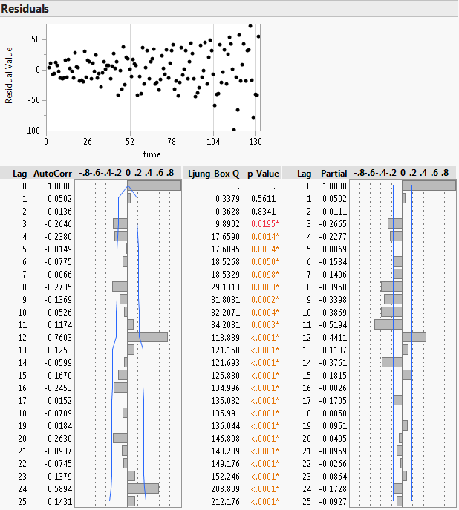
Figure 8: Second Model Results
